TEMASEK POLYTECHNIC
SCHOOL OF INFORMATICS & IT

Logic and Mathematics
Tutorial 2 (Topic: Graphs)

Trees

1. State if each of the following graphs is a tree and provide a reason.

(a)

It is a tree. Any two vertices have a walk between them. There is also no circuit.

(b)

It is not a tree. Any two vertices have a walk between them. However, there is a circuit.

(c)

It is not a tree. The graph is not connected.
2. Suppose that you are working on the human resource system of Company A. Company A has just bought over Company B and will be assimilating all the employees from Company B. Analyze the following organization chart from Company B to see if how it can be assimilated into the existing system of Company A:
D

M3
M2
M1

SE1
SE2
SE3
SE4

E1
E2
E3
E4

A3
A2
A1

(a) What is the level of SE2? 2
(b) What is the level of E2? 3
(c) What is the height of this tree? Height = 4
(d) What are the children of M3? SE2, SE3, SE4
(e) What is the parent of E1? SE1
(f) What are the siblings of A1? A2, A3
(g) What are the descendants of M1? SE1, E1, E2

Spanning Trees

3. Find a spanning tree for the following graph:
v₂
v₅

v₄
v₁

v₃

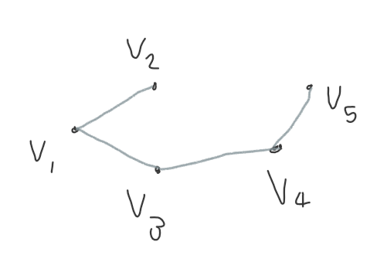

4. The following graph shows part of the Singapore MRT network system. The weights indicate the travel time between two stations and are fictitious. Find the minimum spanning tree for the following graph. Indicate the order in which the edges are added to form the tree.
Little India
Chinatown
Telok Ayer
Outram Park
Bayfront
Downtown
6
4.2
Dhoby Ghaut
Rochor
3.6
Clarke Quay
4.7
5
4.3
Bugis
City Hall
2
3.7
2.5
Promenade
3
4
4.8
4.4
4
4.1
5.3
Tanjong Pager
3.5
Raffles Place

(wrote answer on the next page)

Order | m | Station starting | Station ending | Weight | Action
1 | 1 | Chinatown | Clarke Quay | 2 | Taken
2 | 2 | Chinatown | Telok Ayer | 2.5 | Taken
3 | 3 | Outram Park | Chinatown | 3 | Taken
4 | 4 | Raffles place | Tanjong Pagar | 3.5 | Taken
5 | 5 | Bugis | Rochor | 3.6 | Taken
6 | 6 | Promenade | Bugis | 3.7 | Taken
7 | 7 | City Hall | Raffles Place | 4 | Taken
8 | 7 | Raffles Place | City Hall | 4 | Not taken
9 | 8 | Outram Park | Tanjong Pagar | 4.1 | Taken
10 | 9 | Little India | Rochor | 4.2 | Taken
11 | 10 | City Hall | Bugis | 4.3 | Taken
12 | 11 | Bayfront | Promenade | 4.4 | Taken
13 | 12 | Clarke Quay | Dhoby Ghaut | 4.7 | Taken
14 | 13 | Telok Ayer | Downtown | 4.8 | Taken
15 | 13 | Dhoby Ghaut | City Hall | 5 | Not taken
16 |  | Downtown | Bayfront | 5.3 | Not taken

End

